

Subscribe to DeepL Pro to edit this document.  
Visit [www.DeepL.com/pro](https://www.deepl.com/pro?cta=edit-document) for more information.

**Terms of reference for the development of a feedback collection system**

**1. Project Objective**

Create a system based on the domain

Development of a system for automated collection of feedback from customers who have **used the company's services**. The system should work for B2C companies, collecting evaluations and comments based on email notifications sent to the client.

**2. Functional requirements**

**2.1 System operation scenario**

1. A customer orders a product or service on the company's website, specifying email.
2. After the order is completed, an email is sent to the customer asking for feedback.
3. The customer evaluates the company based on specified criteria (e.g. reliability, speed of delivery, quality of communication, etc.).
4. In case of a low rating (less than 2 stars on one of the criteria), the customer needs to leave a comment before submitting a review.
5. The review goes to the company's personal account, where it can respond or appeal.
6. The average rating of the company is formed based on all ratings and is displayed in a widget on the company's website.
7. There will be other options in the company's personal cabinet

**2.2 Requirements for email notifications**

* Personalization: Email should be personalized and contain customer order details such as **order number**, product/service name and date of purchase.
* Link to order number: Each email should include a unique order number so that the customer can quickly understand which order they are referring to and make it easier to verify the review in the system. This will help avoid confusion and increase the accuracy of the feedback.

Example letter:

*Dear [Customer Name], Thank you for your purchase!*  
*Your order No. [Order Number] (product/service: [Product/Service Name]) has been successfully placed on our website [Company Name]. We would be grateful if you could leave a review about our company. It will take no more than 30 seconds.*

*To rate your purchase and service, please click on the link below:*  
[Leave a Review Button]

* The link to leave a review must be unique and contain the customer's ID and order number in order to track the review.
* Key information in the letter: It should be clear to the customer that he/she is leaving a feedback on this particular order, as well as what data will be used (for example, to analyze the quality of the company's service).

Example link:  
https://сайт-компании.com/оставить-отзыв?order_id=123456&customer_id=7890  
(where order_id is the order number and customer_id is the unique identifier of the customer).

**2.3 Evaluation form**

* Question "Would you recommend our company?" (Yes/No).
* WHEN YOU CLICK YES, ADDITIONAL OPTIONAL QUESTIONS POP UP. WHEN YOU ANSWER **YES,** WITHOUT RATING THE ADDITIONAL QUESTIONS, THE SYSTEM DEFAULTS TO 5 STARS FOR EACH ADDITIONAL QUESTION. QUESTIONS.

If the answer is **NO,** a window will pop up asking you to evaluate all parameters and comment. It should say that without these steps your review cannot be considered verified and published.

* The system will not allow you to publish a review without justification - about that
* Main evaluation criteria (1-5 stars):
  + Reliability
  + Speed of
  + Product availability
  + Quality of communication
  + Convenience of the site

**Make it possible to change the evaluation parameters at the company's request, e.g. remove Delivery Speed and replace it with Packing Quality... (The company itself will enter the evaluation parameters of interest).**

**Feedback Processing Logic:**

* **If the average score is ≥ 4**, the customer can leave a comment (optional).
* **If at least one criterion < 2**, the customer must leave a comment before submitting feedback.
* Negative feedback is highlighted in the system and requires a company response.

Example of displaying a review in your personal cabinet:

📍 **Feedback from Ivanov I.I.**

* Reliability: ⭐⭐⭐⭐⭐
* Speed of delivery: ⭐⭐
* Product Availability: ⭐⭐⭐⭐
* Communication: ⭐⭐⭐⭐⭐
* Website: ⭐⭐⭐⭐⭐

❗ *Customer comment: "Order arrived late, not happy with the service."*

The company can:  
✅ Respond to the customer  
📌 Appeal the feedback

**3. Widget on the company's website**

**Functions:**

* Display the average rating of the company.
* Button to view reviews.
* Ability to filter reviews (positive/negative).
* Important information: an indication **that the system is independent and ensures the honesty of the reviews.**

**Technical Requirements:**

* The widget should be fixed on the right side of the screen, it stays in place when scrolling the page.
* When you hover, a window opens with general information and a "Read Reviews" button.
* Go to the testimonials page on the service domain.

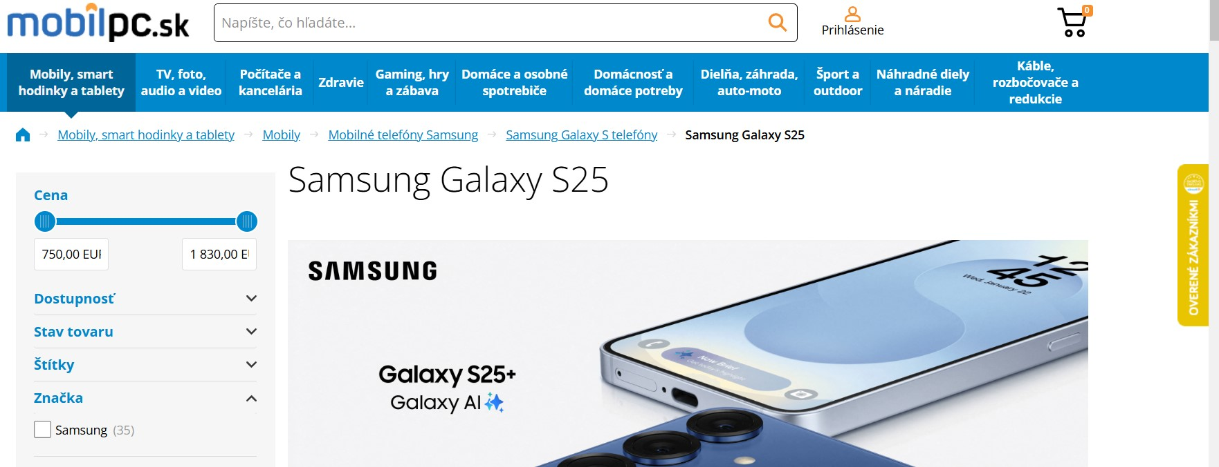**Widget collapsed on the page**

**Widget on hover - pops up**

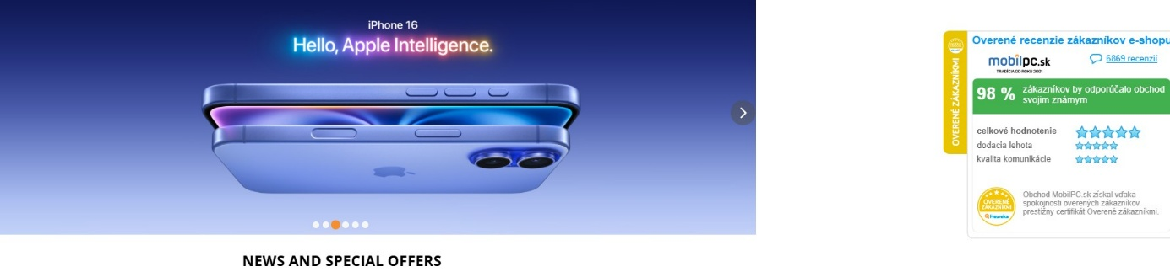

**Widget content**

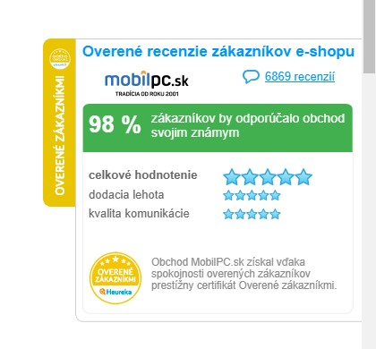  
**Verified customer reviews of the company**

**Company logo**

**Customer comments**

**Overall rating in percent**

**XX% of customers would recommend this company to their friends and relatives**

**Overall rating**

**Speed of delivery**

**Quality of communication**

**Our logo**

**XXXXXXXXX Company has been verified for trustworthy reviews and receives a trust rating**

**Once clicked, it goes to our domain page customer.level-4u.com**

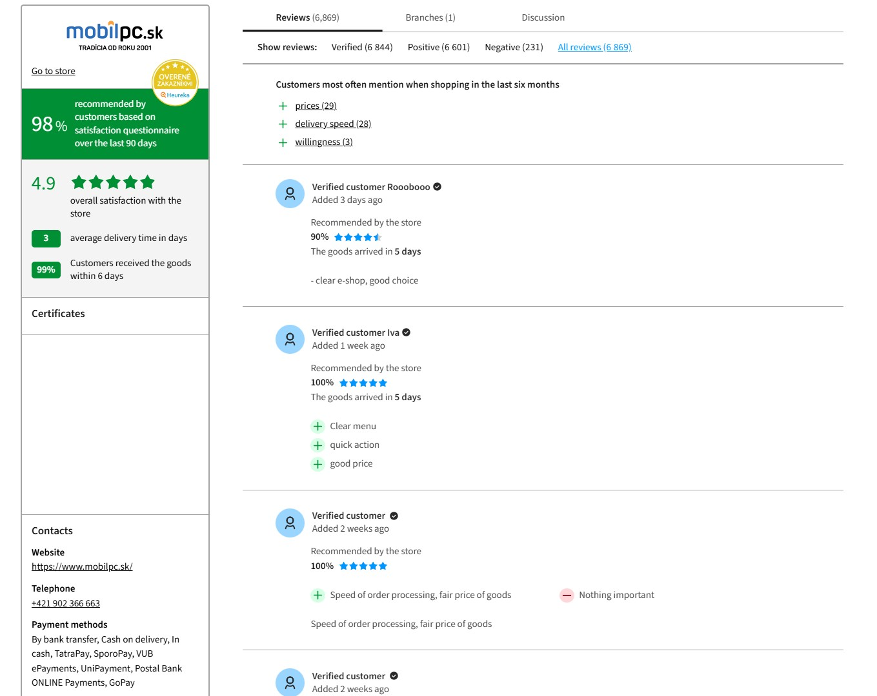

[**https://obchody.heureka.sk/mobilpc-sk/recenze/**](https://obchody.heureka.sk/mobilpc-sk/recenze/)

**Company response**

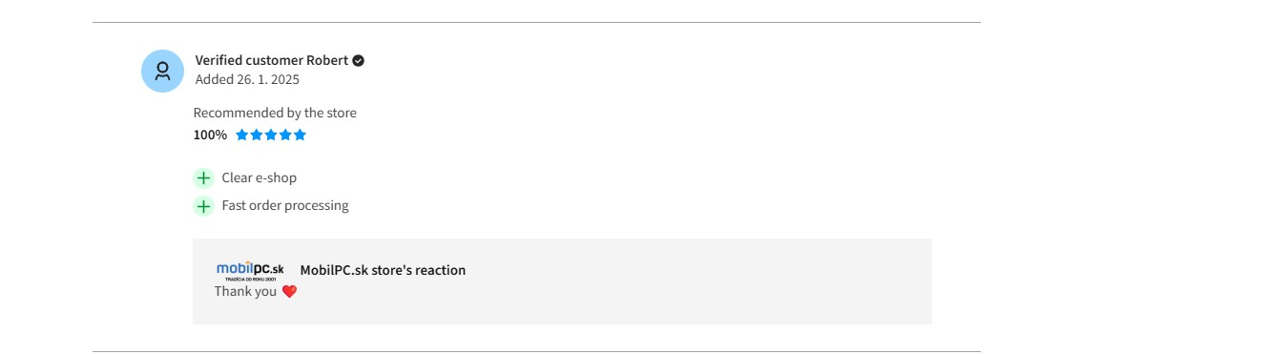

**4. technical requirements**

**4.1 Technology Stack**

* **Back-end**: Python (Django/FastAPI) or Node.js (NestJS)
* **Front-end**: React/Vue.js for personal account and widget
* **Database**: PostgreSQL/MySQL
* **Email newsletters**: SendGrid/Mailgun
* **API**: REST/GraphQL

**6. Integrations**

* Connection to CRM systems (Bitrix24, amoCRM).
* Possibility of API integration with online stores.
* Authorization via OAuth2.

**7. Safety requirements**

* Personal Data Protection (GDPR).
* Limited access to feedback to prevent manipulation.
* Filtering spam and fake reviews.

**8. Timeline and stages of development**

1. **Analysis and design** (1-2 weeks)
2. **MVP development** (4-6 weeks)
3. **Testing and debugging** (2 weeks)
4. **Launch and integration** (2 weeks)

**9. Final requirements**

* The code should be documented.
* Intuitive UI/UX.
* System Scalability.

______________________________________________________________________________

**N1 Personal Cabinet**

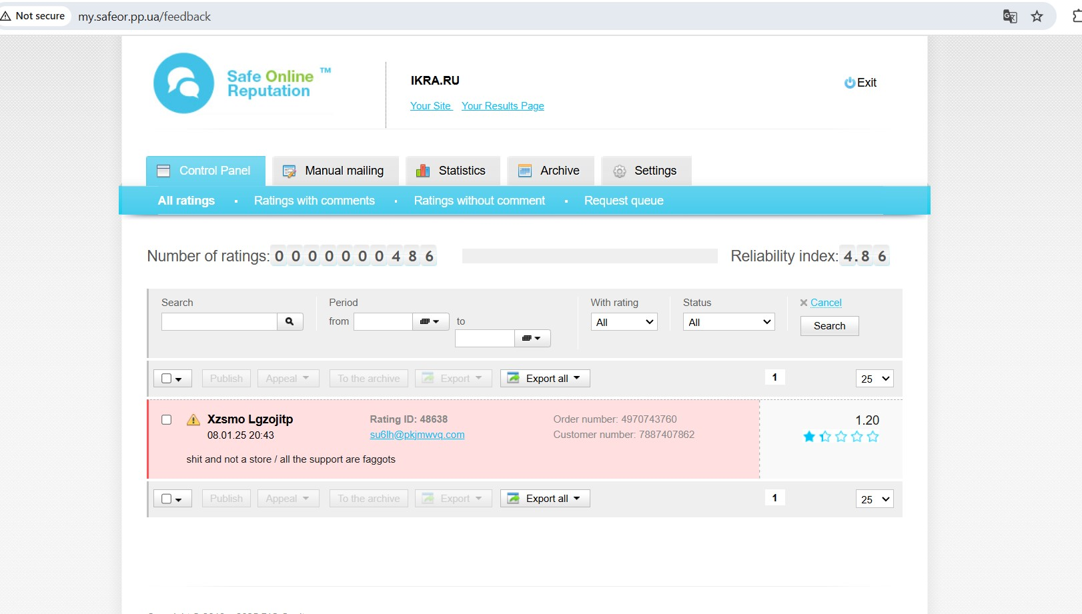

### **Terms of reference for the development of a personal account of the feedback system**

#### **1. general information**

Development of a web interface of the company's personal cabinet for managing customer feedback. Main functions: viewing, filtering, processing and exporting feedback, managing settings and statistics.

#### **2. main interface of the personal account**

**Top menu (navigation bar)**

* **Control Panel** - main control panel (home page). **Add division into Online / Offline reviews**
* **Manual mailing** - manually send email notifications to customers.
* **Statistics** - section with statistical data (graphs, charts on reviews).
* **Archive** - an archive of deleted or inactive reviews.
* **Settings** - system settings (filters, notification settings, widgets, etc.).
* **Exit** - log out of the account.

#### **3. main feedback management screen**

##### **3.1 Filtering feedback**

* **Search" field** - search by keywords, email, order number.
* **Period" filter** - selection of time range.
* Filter **"With rating"** - filter by rating (all, high only, low only).
* **Status" filter** - select the status of the review (active, rejected, under review).
* **Cancel" button** - reset filters.
* **Search" button** - search by the set parameters.

##### **3.2 List of references**

Each review is presented as a line with:

* **Client name** (can be hidden or anonymized).
* **The date and time of** the feedback left.
* **Client Email** (clickable, for contact).
* **Review ID** - a unique identifier in the system.
* **Order number and customer number** - linking to a specific purchase.
* **The text of the review** is the customer's comment.
* **Rating (in stars)** - from 1 to 5.
* **Color Coding**
  + **Red background** - negative feedback (low rating or complaint).
  + **The usual background** is neutral or positive feedback.

#### **4. Feedback management**

* **Checkbox (left)** - the ability to select multiple reviews for mass actions.
* **Publish button** - Publish the review (makes it visible on the site).
* **The "Appeal" button** is for making an appeal (for example, if the review is false or violates the rules).
* **The "To the archive" button** - moves the review to the archive.
* **Export" button** - export the feedback to a file (CSV, Excel, JSON).
* **The "Export all" button** - export all reviews.

**5. Statistics:**

* + Graphs and tables on the number of reviews.
  + Dynamics of rating changes over time.
  + Analyzing the number of positive/negative reviews

### **6. Technical requirements**

* **Frontend:** React/Vue.js (SPA with dynamic filtering and data updating).
* **Backend:** Node.js/Python + REST API.
* **Database:** MySQL/PostgreSQL (or NoSQL for fast performance).
* **UI:** Adaptive design, user-friendly for desktop and mobile devices.

### **Terms of Reference for the development of an offline system of feedback collection using QR codes**

#### **1. Project Objective**

#### To develop a system allowing to collect feedback from clients in offline business points (hairdressers, restaurants, stores, etc.) by means of QR codes. Feedback should be saved in the personal cabinet of the entrepreneur, with the possibility of analyzing them, getting information about the work of a particular branch, point, office, etc. For internal control and tracking of internal processes of the company.

### **2. Functional requirements**

#### **2.1 Generation and management of QR codes**

* Ability to create a unique QR code for each offline point (branch, etc.).
* There should be a section "My QR Codes" in the personal account of the entrepreneur with the possibility:
  + QR code downloads (PNG, SVG).
  + Generating new codes for branches, composing questions for employee evaluations or other internal criteria of your own company.
  + View statistics for each code (number of scans, reviews).

#### **2.2 Feedback page**

* Adaptive mobile web page (PWA) for easy leaving feedback.
* The design should be minimalistic and fast to load.
* Ability to select a rating (1-5 stars).
* Comment field.
* Submit button with download animation.
* A message informing you that the review has been successfully sent.

#### **2.3 Processing and storage of feedback**

* The personal account should display:
  + Recent reviews (filterable).
  + Average business rating.
  + Statistics (graphs of rating changes, percentage of positive/negative feedback).

#### **2.4 Additional functions**

* **Customer motivation:** possibility to customize a bonus (for example, "Leave a review and get a 5% discount").
* **Integration with social networks:** in case of a positive review you are offered to share the link on Instagram, Telegram, etc.
* **Notices**

### **6. Timeline for development**

* System design: **1**
* MVP development: **3**
* Testing and debugging: **2**
* Final launch: **6**

#### **1. Project Objective**

Develop a system that allows collecting feedback from customers at offline business points (hairdressers, restaurants, stores, etc.) by means of QR codes. Feedback should be saved in the personal office of the entrepreneur, with the possibility of analyzing, moderating and integrating it with other services.

### **2. Functional requirements**

#### **2.1 Generation and management of QR codes**

* Ability to create a unique QR code for each offline point.
* The QR code must contain a link to a personalized page for leaving a review.
* There should be a section "My QR Codes" in the personal account of the entrepreneur with the possibility:
  + QR code downloads (PNG, SVG).
  + Generating new codes.
  + View statistics for each code (number of scans, reviews).

#### **2.2 Feedback page**

* Adaptive mobile web page (PWA) for easy leaving feedback.
* The design should be minimalistic and fast to load.
* Ability to select a rating (1-5 stars).
* Optional comment text box.
* If the rating is 1-2 stars, the comment field becomes mandatory.
* Submit button with download animation.
* A message informing you that the review has been successfully sent.

#### **2.3 Processing and storage of feedback**

* Reviews should be stored in a database linked to the QR code, date, time and IP address of the user.
* The personal account should display:
  + Recent reviews (filterable).
  + Average business rating.
  + Ability to respond to feedback.
  + Statistics (graphs of rating changes, percentage of positive/negative feedback).

#### **2.4 Additional functions**

* **Customer motivation:** possibility to customize a bonus (for example, "Leave a review and get a 5% discount").
* **Integration with social networks:** in case of a positive review you are offered to share the link on Instagram, Telegram, etc.
* **Notices**
  + Email notifications to the business owner when there are new reviews.
  + Telegram bot for instant notifications.

### **3. administrative panel (personal cabinet of the entrepreneur)**

Functions:

* Reviewing and moderating reviews.
* QR code generation and management.
* Analytics and statistics on recall.
* Integration settings (CRM, messengers, email newsletters).
* Rate and subscription management.

### **4. technical requirements**

#### **4.1 Backend**

* **Language:** Python (Django) / Node.js (Express)
* **Database:** PostgreSQL /
* **API:** RESTful API for working with frontend and mobile pages.
* **Data Storage:** Secure encryption of customer data.

#### **4.2 Frontend**

* **Admin panel:** React / Vue.js
* **Mobile page (QR testimonials):** HTML + TailwindCSS (PWA)
* **QR code generation:** QRCode.js / library

#### **4.3 Integrations**

* Telegram API (notifications).
* Email SMTP (notifications of new reviews).
* Webhooks for CRM integration.

### **5. Safety and performance**

* Spam protection (reCAPTCHA, query frequency check).
* Restrict repeated reviews (cookie + IP logging).
* Fast page loading (< 1 sec).
* HTTPS + SSL for secure connections

STATISTICS

Create a statistical data section based on the following examples

Here's an example

Website:

http://safeor.pp.ua/

Client login: ikra 1111

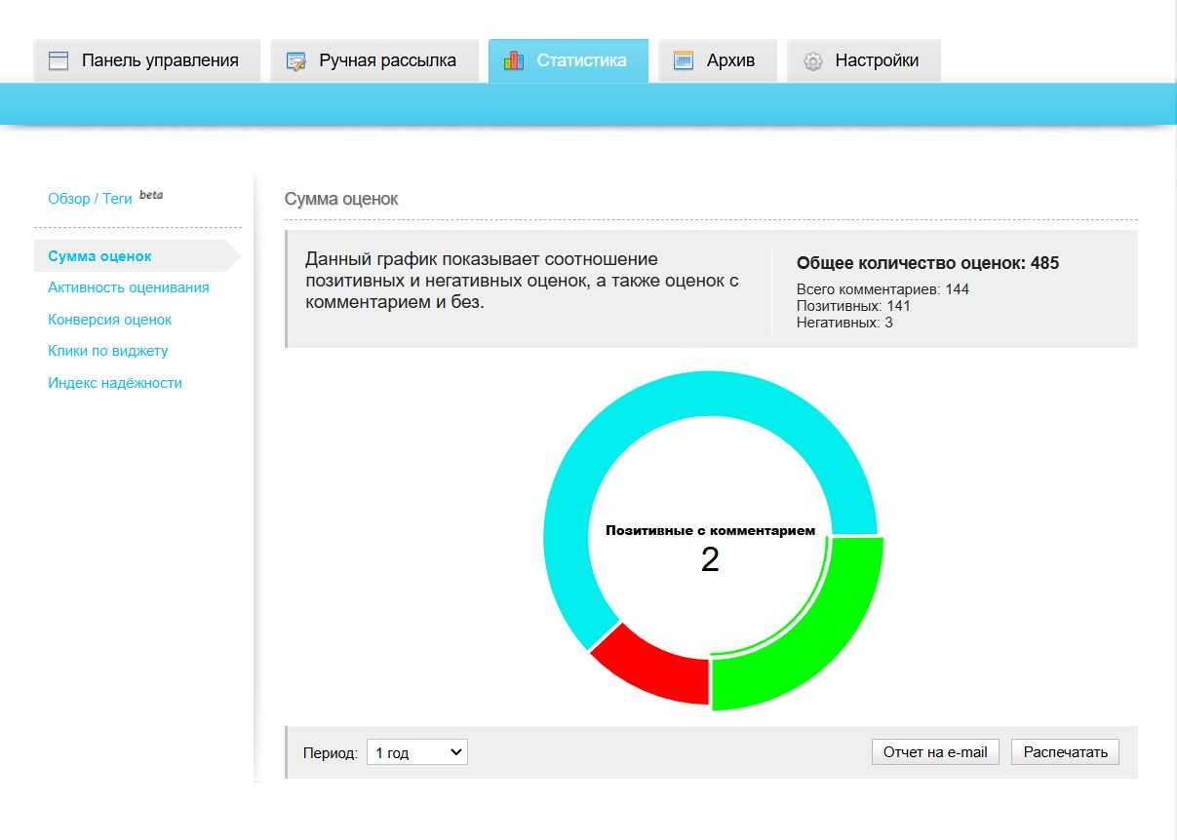2

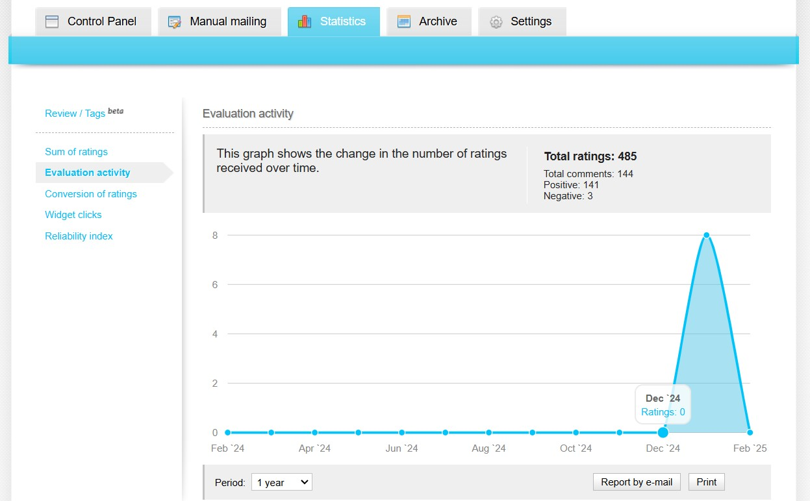

**______________**

**TARIFFS AND DISPLAY IN THE WIDGET**

**1. Basic**

**Trial version 14 days**

50 evaluations per month

Personal cabinet

Basic widget

Defining the survey criteria

One-time mailing

**1st** level of company certification when the rating reaches 90%

__________________________________________________________

**Basic** Tariff Terms of Reference.

-Installing a basic widget on a page

-Pri

-Limit the limit in the system to 50x grades.

-Disable the Statistics button in myAlpari

-When sending a one-time mailing - stop the option

-When the 50th grade is reached, send a notification to the client that the limit is exhausted and they can either purchase the Basic tariff again or offer to switch to the Standart tariff.

-Set a one-time send limit to old customers for initial widget stuffing.

-When you reach 50x grades - stop the ability to enter new grades and the ability to respond and manage in your personal account.

-Limit for additional pop-up questions in user evaluation set to 2 (For example: Logistics, Quality of Communication)

-When the overall rating reaches 90%, send a notification about it and automatically assign our bronze-colored trust certificate with a note (This company can be trusted and has received a bronze-colored trust certificate)

3. **Standard**

**Trial version 14 days**

150 evaluations a month

Basic personal account

Standard widget

Increasing the number of survey criteria

Monthly newsletter

Basic statistics

More information about the company

**2nd** level of company certification when 95% confidence level is reached

Possibility to upgrade to Premium level

__________________________________________________________________

-Installing the widget on the page

-Limit the limit in the system to 150x grades.

-When the 50th grade is reached, send a notification to the client that the limit is exhausted and they can either purchase the Basic tariff again or offer to switch to the Standart tariff.

-Set a one-time send limit to old customers for initial widget stuffing.

-When 150x assessments are reached - stop the ability to receive new assessments and the ability to respond and manage in your personal account. Send a notification with the possibility of payment and reconnection.

-Enable the statistics option

-Set up a monthly newsletter option with date selection etc

-Limit for additional pop-up questions during user evaluation set to 5

-When moving from the widget to the company details page, create additional options to fill in the company information (

-When the overall rating reaches 95%, send a notification about it and automatically assign our Silver trust certificate with a note (This company can be trusted and has received a Silver trust certificate) To separately highlight that the company has reached the level for upgrading to the **Premium** rate

Dear customer, our whole team congratulate you on your home

**3. Premium**

400 evaluations a month

Personalized widget

Full personal account

Unlimited mailing

Analytics and statistics

Implementation of the company's design

3rd level of company certification

Social

**Offline evaluation service**

3rd level of company certification

4. Unique

The tariff is designed for large

companies and is considered on an individual basis.

**Client connection**

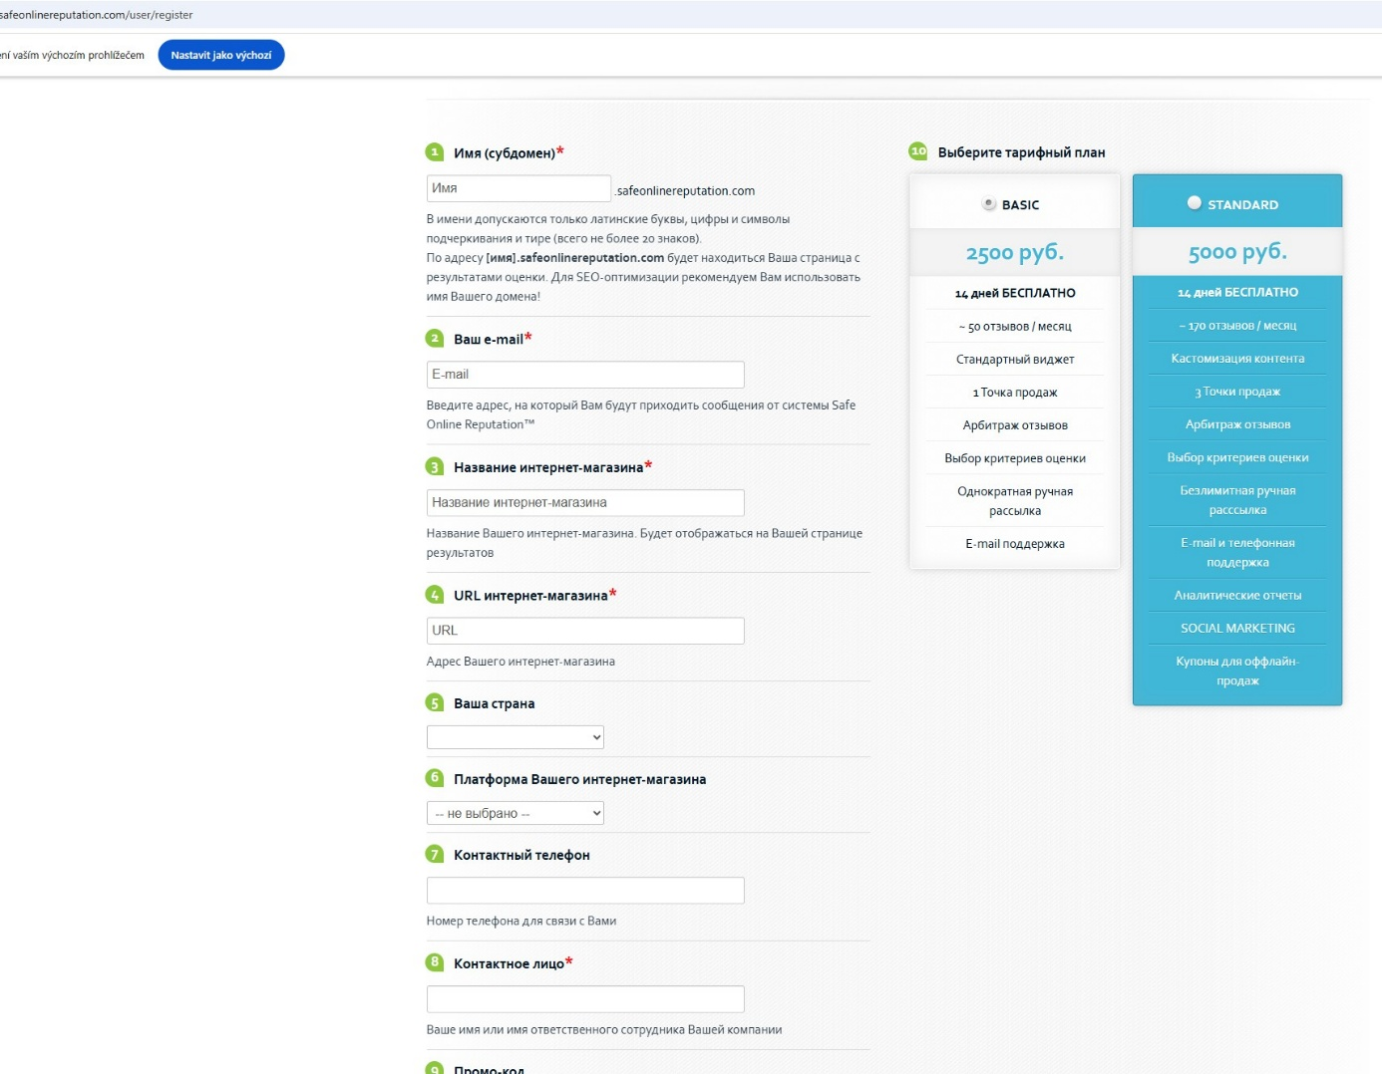

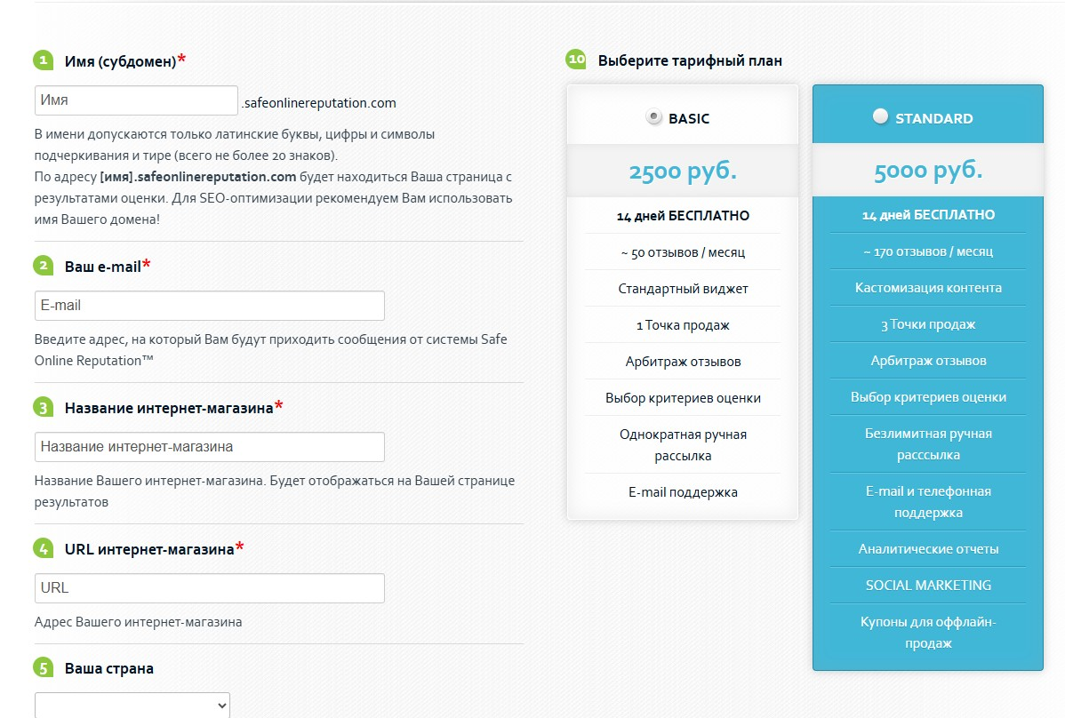

**EXAMPLE ACCESSES**

Website:

http://safeor.pp.ua/

Client login: ikra 1111

Admin:

http://safeor.pp.ua/_sor_admin/ login/password kuklyuk kuklyuk kuklyuk